# DAYANANDA SAGAR ACADEMY OF TECHNOLOGY AND MANAGEMENT

**Accredited by NAAC with Grade A+**

**Autonomous under VTU, Belagavi**



**Engineering Exploration Course (BEEXC208)**

### Project Report

on

**“Design of an IoT-Based Fire Detection and Alert System” “Safety and security in schools/institutions**

**(SDG9)”**

Submitted by

**Vineet K V (1DT24IC049)**

**Adithya Shetty (1DT24IC002) Samiksha Singi (1DT24IC034) Jyoshita N H (1DT24IC015)**

*In partial fulfillment of the requirement for the degree of*

#### BACHELOR OF ENGINEERING

Under the Guidance of **Dr. Roopa R Kulkarni** Associate Professor

Dept. of E&CE, DSATM, Bengaluru



**DAYANANDA SAGAR ACADEMY OF TECHNOLOGY AND MANAGEMENT**

**Accredited by NAAC with Grade A+**

Udayapura, Kanakapura Road, Bengaluru-560082

**Academic Year 2024-2025**

# DAYANANDA SAGAR ACADEMY OF TECHNOLOGY AND MANAGEMENT

**Autonomous under VTU, Belagavi Accredited by NAAC with Grade A+** Udayapura, Kanakapura Road, Bengaluru-560082



This is to satisfy that the **Engineering Exploration Course** project work entitled “**Design of an IoT-Based Fire Detection and Alert System**” under the **“Safety and security in schools/institutions (SDG9)”** carried out by **Vineet K V (1DT24IC049), Adithya Shetty (1DT24IC002), Samiksha Singi (1DT24IC034), Jyoshita N H (1DT24IC015),** bonafide students of **DAYANANDA SAGAR ACADEMY OF TECHNOLOGY AND MANAGEMENT** in Bachelor of Engineering of Visvesvaraya Technological University, Belagavi during the academic year 2024-2025. It is certified that all the corrections/suggestions indicated for internal assessment have been incorporated in the report. The project report has been approved as it satisfies the academic requirement in respect of the Engineering Exploration Course prescribed for the degree.

|  |  |  |
| --- | --- | --- |
| **Signature of Coordinator** | **Signature of Guide** | **Signature of the Principal** |
| **Dr. Roopa R Kulkarni** | **Dr. Roopa R Kulkarni** | **Dr. M. Ravishankar** |

External Viva Name of the Examiner Signature with date

1.

2.

# ACKNOWLEDGEMENT

We are deeply grateful for the support and guidance that made this project possible.

First and foremost, we would like to express our sincere thanks to the Management of Dayananda Sagar Academy of Technology and Management, Bengaluru, for providing the necessary resources and a conducive environment to carry out this project.

Our heartfelt gratitude goes to our Principal, Dr. M. Ravishankar, for his constant encouragement and for fostering a culture of academic excellence.

We are immensely thankful to our Project Guide, Dr. Roopa R. Kulkarni, Associate Professor, Department of Electronics and Communication Engineering, for her invaluable insights, constructive feedback, and unwavering support throughout the duration of this project. Her expertise and dedication have been instrumental in shaping the direction and outcome of our work.

We would also like to extend our appreciation to our Project Coordinator, Dr. Roopa R. Kulkarni, for her well-structured guidelines and clear framework, which ensured that the project progressed smoothly and met all required milestones.

Lastly, we acknowledge the hard work and dedication of our team members. This project would not have been possible without their collaboration, creativity, and commitment.

Thank you all for your support and encouragement.

Sincerely,

Vineet K V (1DT24IC049)

Adithya Shetty (1DT24IC002) Samiksha Singi (1DT24IC034) Jyoshita N H (1DT24IC015)

# ABSTRACT

This project presents the design and implementation of a smart fire detection system using Internet of Things (IoT) technology, aiming to overcome the limitations of traditional fire alarm systems. Existing systems primarily rely on manual activation or basic smoke detection and often lack real-time monitoring, remote communication, and integration with smart technologies. The increasing incidents of fire-related hazards in educational institutions underscore the need for more efficient and responsive systems. Our proposed solution integrates smoke and temperature sensors with an ESP32 microcontroller to monitor environmental conditions continuously. The system activates a buzzer and sends real-time notifications via the Blynk mobile application only when both gas and temperature thresholds are breached, thereby minimizing false alarms. The methodology encompasses a literature review, system design using embedded hardware and software, IoT platform integration, and extensive testing in simulated environments. Hardware components include the MQ2 gas sensor, DHT11 temperature sensor, and ESP32 microcontroller. The software was developed using Arduino IDE and the Blynk IoT platform. The system was tested for accuracy, reliability, and responsiveness. Results confirm the successful operation of the system, with alerts accurately triggered under defined hazardous conditions. Future scope includes adding AI-based predictive analytics, enhancing scalability, integrating evacuation guidance, and developing security protocols for system robustness. This solution bridges the gap between conventional systems and modern safety needs, offering a cost-effective, user-friendly, and scalable platform for fire safety in institutions.

**TABLE OF CONTENTS**

|  |  |  |  |
| --- | --- | --- | --- |
| **Chapter No.** | **Contents** | | **Page No** |
| 1 |  | Introduction | 1 |
|  | 1.1 | Organization of the Report | 3 |
| 2 |  | Design thinking approach | 5 |
|  | 2.1 | Introduction | 6 |
|  | 2.2 | Sustainable Development Goals | 7 |
|  | 2.3 | Customer Research | 9 |
|  | 2.4 | Empathy Map | 10 |
|  | 2.5 | Customer Journey Map | 11 |
|  | 2.6 | Need Statement to Problem definition | 12 |
|  | 2.7 | Existing System | 12 |
|  | 2.8 | Objectives | 15 |
|  | 2.9 | Project Management | 15 |
|  |  | 2.9.1 Identifying Milestones | 16 |
|  |  | 2.9.2 Project Execution Plan | 16 |
| 3 |  | Methodology and Implementation | 19 |
|  | 3.1 | Hardware requirement | 20 |
|  | 3.2 | Software requirement | 22 |
|  | 3.3 | Flow diagram/block diagram/Algorithm | 23 |
|  | 3.4 | Hardware implementation | 25 |
|  | 3.5 | Software implementation | 30 |
| 4 |  | Result and discussion | 35 |
| 5 |  | Conclusion and Future Scope | 43 |
| 6 |  | Our journey experience and take away | 45 |
|  |  | References | 52 |
|  |  | Appendix 1 – datasheet of Sensors | 54 |

**LIST OF FIGURES**

|  |  |  |
| --- | --- | --- |
| **Figure No.** | **Name of the figure** | **Page No** |
| 2.1 | Introduction to Design Thinking | 6 |
| 2.2 | SDG Goals | 7 |
| 2.3.1 | Persona Map of Student staying in Campus’ Hostel | 9 |
| 2.3.2 | Persona Map of Security Guards | 9 |
| 2.4 | Empathy Map for Student | 11 |
| 2.5 | Customer Journey Map (Security Guard) | 12 |
| 3.1.1 | ESP32 | 20 |
| 3.1.2 | MQ2 Gas Sensor | 21 |
| 3.1.3 | DHT11 | 21 |
| 3.1.4 | Buzzer | 22 |
| 3.1.5 | LEDs | 22 |
| 3.1.6 | Jumper Wires | 22 |
| 3.3 | Block Diagram | 24 |
| 3.4.1 | Circuit Pin Connection Diagram | 29 |

|  |  |  |
| --- | --- | --- |
| 3.4.2 | Prototype Circuit Overview | 29 |
| 3.5.1 | Code Snippet 1 | 31 |
| 3.5.2 | Code Snippet 2 | 31 |
| 3.5.3 | Code Snippet 3 | 31 |
| 3.5.4 | Code Snippet 4 | 31 |
| 3.5.5 | Code Snippet 5 | 32 |
| 3.5.6 | Code Snippet 6 | 32 |
| 3.5.7 | Code Snippet 7 | 32 |
| 3.5.8 | Code Snippet 8 | 33 |
| 3.6 | Flow Diagram | 34 |
| 4.2.1 | Threshold Conditions Met | 37 |
| 4.2.2 | Email Notification when Fire is Detected | 37 |
| 4.2.3 | DHT11 Sensor not Connected | 38 |
| 4.2.4 | Blynk Dashboard upon disconnecting DHT11 Sensor | 38 |
| 4.2.5 | Email sent upon disconnecting DHT11 Sensor | 39 |
| 4.2.6 | MQ2 Sensor not Connected | 39 |

|  |  |  |
| --- | --- | --- |
| 4.2.7 | Blynk Dashboard upon disconnecting MQ2 Sensor | 40 |
| 4.2.8 | Email sent upon disconnecting DHT11 Sensor | 40 |

**LIST OF TABLES**

|  |  |  |
| --- | --- | --- |
| **Table No.** | **Name of the Table** | **Page No** |
| 1 | Gann Chart for Project Execution | 17 |
| 2 | Research Paper Summary | 54 |
| 3 | ESP32 Microcontroller Datasheet | 56 |
| 4 | MQ2 Gas Sensor Datasheet | 56 |
| 5 | MQ2 Gas Sensor Datasheet | 57 |

Design of an IoT-Based Fire Detection and Alert System 2024-25

CHAPTER 1 INTRODUCTION

## CHAPTER 1 INTRODUCTION

Fire safety is a critical aspect of infrastructure design and operation, particularly in educational institutions where a large population gathers daily. Traditional fire safety systems, often limited to manual alarms or basic smoke detectors, frequently lack the real-time alerting capabilities and smart integration necessary for rapid and effective emergency response. This deficiency can lead to significant delays during fire emergencies, compounded by the absence of remote monitoring, automated communication, and precise hazard detection. The evolving complexity of modern building environments further demands more intelligent, agile, and interconnected fire safety solutions to protect human life and property.

This project addresses the critical need for an advanced, IoT-based fire detection system capable of continuous environmental monitoring, detecting both smoke/gas and temperature anomalies, and instantly notifying relevant individuals via a mobile application. The system is designed to trigger a local audible alert only when both gas and temperature thresholds are confirmed to be exceeded, thereby reducing false alarms and improving reliability. The primary objective is to develop a low-cost, efficient, and scalable solution suitable for real-time safety monitoring in educational institutions.

The methodology employed in this project integrates principles of Design Thinking, focusing on a human- centric approach to problem-solving. Design Thinking is an iterative, non-linear process that involves understanding users, challenging assumptions, redefining problems, and creating innovative solutions through prototyping and testing. The five phases—Empathize, Define, Ideate, Prototype, and Test—ensure a comprehensive and user-focused development process. This approach has been instrumental in identifying critical gaps in existing fire safety measures and guiding the development of a more responsive and accessible system. The project also aligns with Sustainable Development Goal (SDG) 9, which emphasizes industry, innovation, and infrastructure, specifically addressing safety and security in schools and colleges to foster a positive learning environment.

Existing fire safety systems often rely on conventional setups, which struggle with real-time detection, proper integration of IoT frameworks, and a heavy dependence on simulations without field validation. While these systems have evolved, the increasing occurrence of fire-related incidents underscores their shortcomings in terms of responsiveness, scalability, and user engagement. Previous research highlights the need for systems that incorporate IoT sensors and AI algorithms for real-time detection, remote monitoring, and faster

emergency response, along with human-centric evacuation models and standardized safety assessment frameworks.

The motivation for this project stems from identified limitations in traditional fire safety protocols within educational settings. The project aims to enhance safety by leveraging smart technology to provide timely and accurate alerts, thereby improving response times and overall security.

Customer research, primarily conducted through surveys and feedback, revealed several critical problems related to safety and security in schools and institutes. These include:

* Lack of awareness regarding emergency resources among students, leading to confusion.
* Inconsistent enforcement of security measures, creating vulnerabilities.
* Vulnerability and safety concerns, especially during late hours.
* Uncertainty about the effectiveness of existing emergency protocols.
* Parental concerns over child safety and institutional preparedness.
* Lack of timely and clear communication with parents during incidents.
* Insufficient resources or training for security staff.
* Student disregard for security protocols.
* Physical and mental fatigue experienced by security personnel due to constant vigilance. These insights underscore the need for a more robust, integrated, and user-friendly safety system.

The project successfully designed and implemented a smart and affordable IoT-based fire detection system using an ESP32 microcontroller, MQ2 gas sensor, and DHT11 temperature and humidity sensor. The system monitors fire-related hazards in real-time and provides immediate alerts through the Blynk mobile application. By requiring both temperature and gas thresholds to be crossed before triggering an alert, the system effectively reduces false alarms and enhances reliability. This solution is scalable, user-friendly, and practical for real-world fire safety applications, demonstrating how smart technology can significantly improve safety in educational institutions and public spaces.

### 1.1 ORGANIZATION OF THE REPORT

This report is organized into six chapters. **Chapter 1: Introduction** introduces the context of fire safety in institutional environments, outlines the problem statement, methodology, and project motivation. **Chapter 2: Design Thinking Approach** explains the use of the design thinking methodology in system development, including empathy maps, customer research, journey mapping, and alignment with Sustainable Development Goals. **Chapter 3: Methodology and Implementation** describes the hardware and software used, includes technical diagrams such as block diagrams and circuit layouts, and explains the operational flow of the system. **Chapter 4: Result and Discussion** details the performance of the system under various testing conditions, supported by visuals, and discusses the accuracy and effectiveness of alerts. **Chapter 5: Conclusion and**

**Future Scope** summarizes key outcomes and outlines potential enhancements for future versions of the system. **Chapter 6: Our Journey Experience and Takeaway** reflects on team collaboration, technical learning, problem-solving experience, and individual growth.

CHAPTER 2

DESIGN THINKING APPROACH

## CHAPTER 2

DESIGN THINKING APPROACH

The Design Thinking methodology served as an indispensable guiding principle throughout the development of this IoT-based fire detection system. Its structured yet flexible framework enabled a deep dive into the complex landscape of fire safety, ensuring that the final solution was not merely a technological feat but a truly human-centered innovation. This approach facilitated a profound understanding of user needs, leading to the creation of a system that is intuitive, reliable, and genuinely addresses real-world safety challenges.

### Introduction to Design Thinking

Design Thinking is fundamentally a problem-solving methodology that prioritizes understanding the user's perspective. Unlike traditional linear approaches, it is characterized by its non-linear and iterative nature, constantly cycling through phases of empathy, definition, ideation, prototyping, and testing. This cyclical process allows for continuous refinement and adaptation based on feedback and new insights. The core objective is to challenge existing assumptions, redefine problems from a user-centric viewpoint, and generate innovative solutions that are not only technologically viable but also desirable to the end-users and economically feasible for deployment. By fostering creativity and collaboration, Design Thinking ensures that solutions are holistic and user-friendly, directly addressing the pain points identified in the problem space.

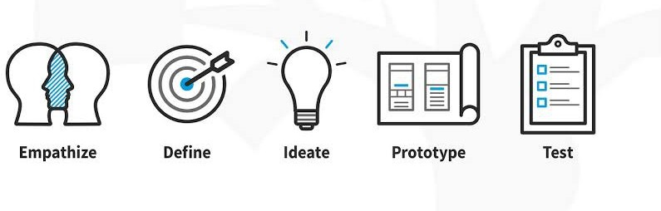

Figrue 2.1: Introduction to Design Thinking [18]

### Sustainable Development Goals (SDGs)

The Sustainable Development Goals are a universal blueprint adopted by the United Nations in 2015 to achieve a better and more sustainable future for all by the year 2030. There are 17 interconnected goals that address global challenges such as poverty, inequality, health, education, and climate change.



Figure 2.2: SDG Goals [19]

The **Sustainable Development Goals (SDGs)** are a universal framework established by the **United Nations** in 2015, comprising 17 interlinked goals intended to be achieved by 2030. These goals aim to address global challenges such as poverty, inequality, climate change, environmental degradation, peace, and justice. The SDGs serve as a comprehensive blueprint for sustainable development and guide individuals, institutions, and governments toward building a more equitable and resilient world. A brief overview of the 17 SDGs is as follows:

1. **No Poverty**: Eliminate poverty in all its forms by ensuring access to essential resources, services, and social protection mechanisms.
2. **Zero Hunger**: End hunger, achieve food security, improve nutrition, and promote sustainable agriculture practices.
3. **Good Health and Well-being**: Ensure healthy lives and promote well-being for individuals of all ages through access to quality healthcare and preventative measures.
4. **Quality Education**: Ensure inclusive and equitable quality education and promote lifelong learning opportunities for all.
5. **Gender Equality**: Achieve gender equality and empower all women and girls by eliminating discrimination and ensuring equal rights and opportunities.
6. **Clean Water and Sanitation**: Ensure availability and sustainable management of clean water and sanitation for all populations.
7. **Affordable and Clean Energy**: Ensure access to affordable, reliable, sustainable, and modern energy sources.
8. **Decent Work and Economic Growth**: Promote sustained, inclusive, and sustainable economic growth, full and productive employment, and decent work for all.
9. **Industry, Innovation, and Infrastructure**: Build resilient infrastructure, promote inclusive and sustainable industrialization, and foster innovation.
10. **Reduced Inequalities**: Reduce inequality within and among countries through inclusive policies and equal access to opportunities.
11. **Sustainable Cities and Communities**: Make cities and human settlements inclusive, safe, resilient, and sustainable through strategic urban planning and infrastructure.
12. **Responsible Consumption and Production**: Ensure sustainable consumption and production patterns through resource efficiency and waste reduction.
13. **Climate Action**: Take urgent action to combat climate change and its impacts by strengthening resilience and adaptive capacity.
14. **Life Below Water**: Conserve and sustainably use the oceans, seas, and marine resources to support sustainable development.
15. **Life on Land**: Protect, restore, and promote the sustainable use of terrestrial ecosystems, manage forests, combat desertification, and halt biodiversity loss.
16. **Peace, Justice, and Strong Institutions**: Promote peaceful and inclusive societies, ensure access to justice for all, and build effective, accountable institutions.
17. **Partnerships for the Goals**: Strengthen the means of implementation and revitalize global partnerships to support the achievement of all SDGs.

In the context of this project, our work aligns with:

* + **SDG 9**: *Industry, Innovation, and Infrastructure* — which emphasizes building resilient infrastructure and fostering innovation. Our IoT-based fire detection system exemplifies this goal by promoting safety innovation in educational institutions.

This project aligns with the United Nations Sustainable Development Goal 9: “Build resilient infrastructure, promote inclusive and sustainable industrialization and foster innovation.” Fire safety is an essential aspect of

resilient infrastructure, and our IoT-based system enhances that resilience through innovation and inclusivity. The project promotes scalable and sustainable safety solutions that can be deployed in diverse educational settings at minimal cost.

### Customer Research

Customer research is the process of gathering qualitative and quantitative data about users’ needs, preferences, challenges, and behaviours. This research ensures that the solution addresses real user problems and provides meaningful value. In our case, customer research involved surveys, interviews, and observations of students, hostel wardens, and campus security to understand their experience with existing fire safety measures.

Primary and secondary research was conducted to understand the needs, pain points, and safety behaviors of various campus stakeholders. The methods used included:

* Questionnaires and online surveys distributed to 50+ students.
* Interviews with hostel wardens and campus security personnel.
* Informal focus group discussions in academic departments.

#### Key Insights:

* Most students were unaware of fire evacuation procedures.
* There were no regular fire drills conducted in many departments.
* Fire extinguishers were often inaccessible or non-operational.
* Users preferred mobile notifications over loud alarms, especially in hostels.
* Concerns about false alarms from cooking smoke in dorms.

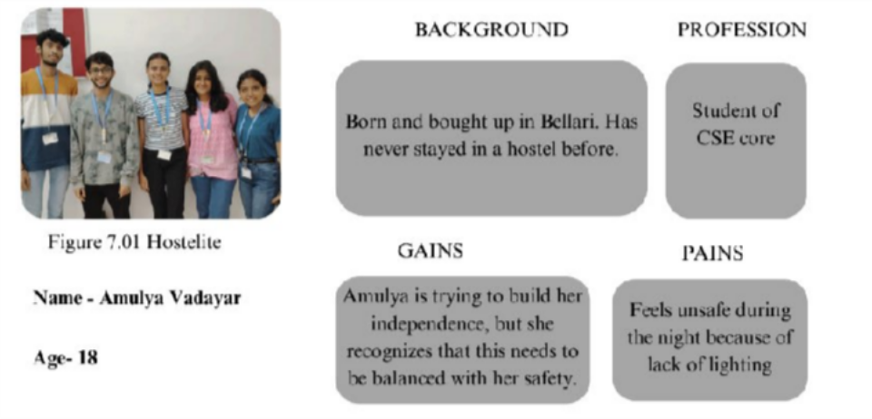

Figure 2.3.1: Persona Map of Student staying in Campus’ Hostel

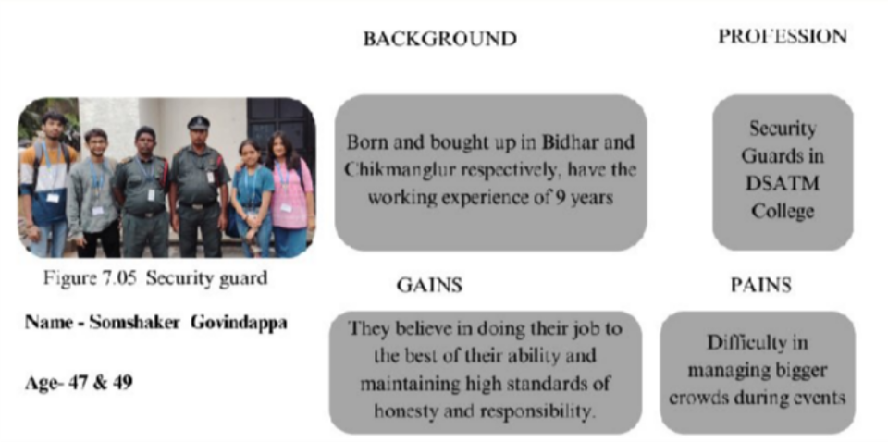

Figure 2.3.2: Persona Map of Security Guards

### Empathy Map

An empathy map is a collaborative tool used to gain deeper insight into users. It visualizes what the user says, thinks, does, and feels, allowing the design team to understand user pain points and expectations. This helps prioritize features that genuinely improve user experience. For our project, the empathy map captured insights such as anxiety about emergency procedures and a strong preference for mobile alerts.

To synthesize our findings, we created an empathy map to capture the perspectives of a typical campus resident:

* **Says:** “I don’t know where the nearest fire exit is.”
* **Thinks:** “I wish alerts came directly to my phone.”
* **Does:** Ignores alarm drills and warning signs.
* **Feels:** Anxious and unsure during safety incidents.

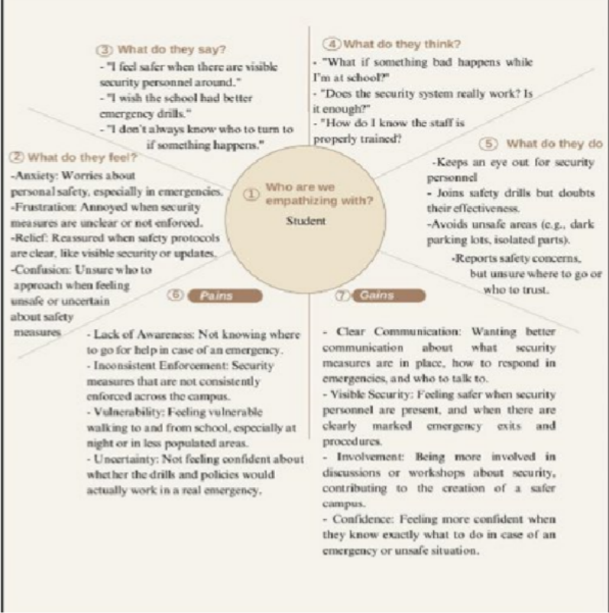

Figure 2.4: Empathy Map for Student

### Customer Journey Map

A customer journey map is a diagram that illustrates the steps a user goes through when interacting with a system, especially during critical situations like emergencies. It highlights user actions, emotions, and touchpoints at each stage of the experience. In fire safety, this includes detection, alerting, evacuation, and resolution. Mapping this journey helped us identify where traditional systems fail and how real-time IoT alerts can enhance user response.

A journey map was constructed to model how a user typically interacts with fire safety systems during a hazard event:

1. **Pre-Incident** – User unaware of emerging hazard.
2. **Detection** – Sensors detect elevated temperature and gas.
3. **Alerting** – Notification sent via Blynk app; buzzer activates.
4. **Response** – User acknowledges alert and evacuates.
5. **Post-Incident** – Data logged and reviewed for further action.

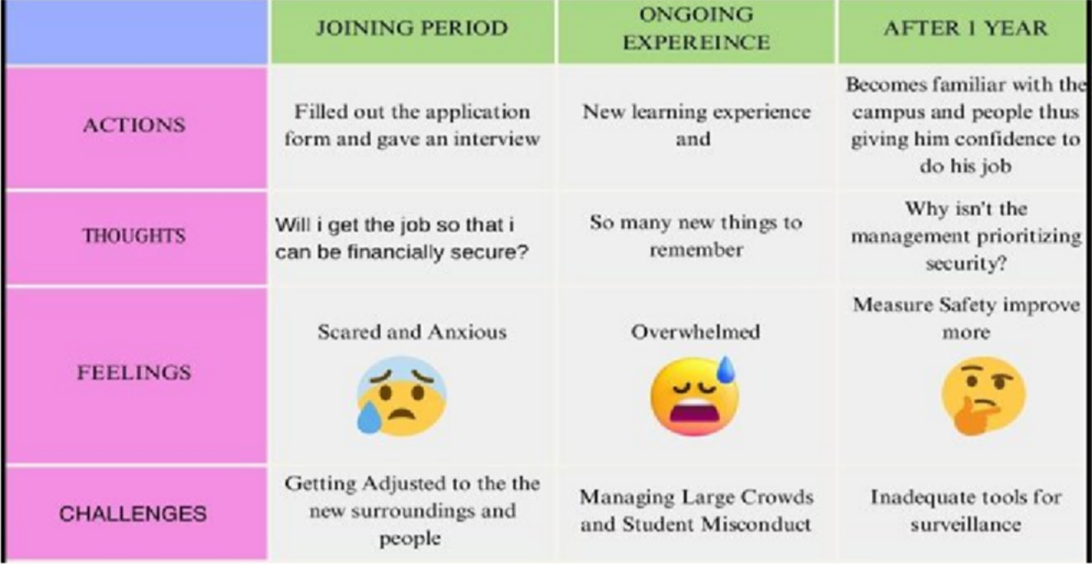

Figure 2.5: Customer Journey Map (Security Guard)

### Need Statement to Problem Definition

The transition from broad need statements, identified during the empathy phase, to precise and actionable problem definitions was a crucial step in the Design Thinking process. For example, the initial observation that "*people need to be safer during fires*" was refined into a more specific and solvable problem statement. This involved articulating the core gaps in existing systems—such as "*traditional fire safety systems lacking real-time alerting and smart integration*"—and explicitly linking these gaps to negative consequences, like "*delayed response times and inadequate communication*" during emergencies. This rigorous process of problem definition ensured that the project maintained a clear focus on addressing verifiable and impactful challenges, thereby guiding the subsequent ideation and solution development with precision and purpose.

### Existing System

A thorough and systematic literature survey was conducted to contextualize the present project within the broader domain of fire safety systems. This extensive review involved a critical examination of contemporary academic research and an analytical assessment of commercially available fire safety products. The objective was to identify prevailing trends, highlight technological advancements, and, crucially, pinpoint existing gaps and limitations that our proposed IoT-based system aims to address and overcome.

**Summary of Research Papers:** A total of eight research papers were reviewed to establish a foundational understanding of existing fire safety systems and to identify gaps that informed the development of the proposed IoT-based solution. These studies explored various aspects of fire detection, evacuation modelling, system integration, and performance benchmarking across residential, commercial, and institutional contexts. A summary of key findings from the reviewed literature is presented below:

* **I. M. Al Shereiqi and M. Sohail (2019) [1]** proposed a smart fire alarm system using IoT. Although the system leveraged connected sensors, the paper noted limitations in terms of real-time responsiveness and integration with broader alert mechanisms.

**K. Kumar and V. K. Pau (2022) [2]** emphasized the importance of reliability in fire protection systems. The study highlighted the consequences of component failure and stressed the need for redundancy and intelligent logic to improve safety outcomes.

*Reference: Significance of Fire Protection System Reliability for Structure Fire Safety, Structural Engineering Digest.*

* **M. Xu and D. Peng (2020) [3]** conducted a simulation-based study using PyroSim to analyze evacuation behavior in college buildings. The research provided valuable theoretical insights but lacked field validation, exposing a gap between simulation accuracy and real-world applicability.
* **F. Zahmatkesh and A. M. Memari (2017) [4]** reviewed both conventional and innovative retrofitting methods for fire protection in existing buildings. The study recommended adopting new technologies but acknowledged challenges in cost and implementation.
* **G. Alfalah et al. (2023) [5]** developed a fire safety assessment model using the Analytic Hierarchy Process (AHP). The study identified the absence of standardized frameworks as a barrier to effective safety evaluation and improvement.

*Reference: Development of Fire Safety Assessment Model for Buildings Using AHP, Applied Sciences.*

* **R. P. Singh (2022) [6]** presented an overview of alarm systems used in fire detection. The paper emphasized the limitations of traditional systems, including high false alarm rates and lack of real- time user feedback.

**V. Kodur, P. Kumar, and M. M. Rafi (2020) [7]** examined fire hazards in buildings, highlighting the disconnect between fire modelling and actual human behaviour during evacuation. The paper also stressed the need for integrated, human-centric safety strategies.

**T. Eremina and D. Korolchenko (2020) [8]** studied the use of intumescent coatings for structural fire protection. While effective for passive protection, the paper acknowledged that such methods alone cannot guarantee early detection or remote alerting.

These studies collectively reveal critical gaps such as the lack of real-time monitoring, insufficient IoT integration, overreliance on simulations, and absence of standardized assessment tools. The proposed project directly addresses these limitations by combining dual-sensor logic, mobile-based alerts, and scalable IoT integration to deliver a practical, user-centered fire detection solution for educational institutions.

**Summary of Products:** The analysis extended to several commercially available fire safety products in the current market. While these products offer a variety of features—ranging from basic smoke and heat detectors to advanced smart home integrations—multiple common shortcomings were identified:

#### High Cost-Effectiveness Barriers:

Advanced commercial systems, particularly those offering comprehensive smart features and professional monitoring services, often involve substantial upfront costs and recurring subscription fees. Such financial requirements make them less viable for budget-constrained institutions, especially educational facilities.

#### Challenges in Scalability and Deployment:

The deployment of complex fire safety systems across expansive or multi-building campuses poses significant logistical challenges. These include extensive wiring requirements, infrastructure modifications, and time-consuming configuration processes, which collectively hinder widespread adoption.

#### Limited Customization Options:

Many commercial products come with predefined features and fixed alert mechanisms, limiting the flexibility to adapt the system to specific institutional needs. Examples include restricted control over sensor placement, alert routing, and user-defined notification groups.

#### Integration with Specific Communication Channels:

Although some products support integration with proprietary mobile applications, they often lack the ability to send alerts across a broader stakeholder network. Integration with flexible, widely accessible platforms such as Blynk is rarely supported, reducing usability across diverse user roles.

#### Prevalence of False Alarms:

Single-sensor-based systems are prone to false alarms triggered by non-critical events such as cooking fumes, steam, or dust. This desensitizes users over time and may contribute to delayed reactions in actual emergency scenarios.

**Comparative Analysis:** A comparative analysis was conducted to assess how the proposed *IoT-based fire detection system* performs in relation to existing *research models* and *commercial products*. The evaluation was based on several key factors, including **detection accuracy**, **real-time responsiveness**, **IoT integration**, **cost-effectiveness**, **scalability**, and the **comprehensiveness of alert mechanisms**. Existing academic

approaches often rely heavily on *simulations or theoretical models* and lack *practical implementation* or *field validation*. Commercial systems, while more *reliable* in real-world use, are frequently **expensive**, **difficult to scale** in institutional settings, and offer **limited customization**. In contrast, the proposed system addresses these shortcomings through a **dual-sensor activation mechanism** that enhances *accuracy* and reduces *false alarms*. It also utilizes **open-source, cost-effective components** such as the *ESP32*, *MQ2 gas sensor*, and *DHT11 temperature sensor*, making it **accessible for educational institutions** with limited budgets. Integration with the **Blynk IoT platform** allows for **real-time data monitoring** and **mobile-based alerts**, ensuring *immediate communication* with multiple stakeholders. Additionally, the system’s **modular design** supports *future scalability* and *customization* based on institutional needs. This positions the prototype as a **practical**, **reliable**, and **affordable** alternative to traditional fire detection solutions.

### Objectives

This project aims to:

* **Build** a low-cost and scalable fire detection system based on **ESP32** microcontroller technology, making it accessible for educational institutions and similar environments.
* **Incorporate** both **MQ2 gas** and **DHT11 temperature sensors** to implement a **dual- validation mechanism**, ensuring greater accuracy in hazard detection.
* **Leverage** the **Blynk IoT platform** for creating a seamless and user-friendly notification system.
* **Deliver** real-time alerts directly to users’ **mobile devices**, facilitating rapid response and increased situational awareness.
* **Reduce false positives** while maintaining high sensitivity to genuine fire risks, striking a balance between reliability and responsiveness.

### Project Management

Effective project management served as a crucial pillar for the successful execution of this technically driven project. It was not merely an administrative task but a strategic function that involved **careful planning**, **judicious resource allocation**, and **continuous progress tracking**. These practices ensured that each phase of the project—from ideation and design to implementation and testing—advanced systematically and aligned with the defined objectives and timelines. The emphasis on coordination and timely decision-making played a key role in maintaining project momentum and quality.

### Identifying Milestones

The project lifecycle was systematically segmented into several distinct, quantifiable milestones. This structured approach allowed for clear progress tracking, facilitated timely decision-making, and ensured accountability across the team. Key milestones included:

* + - * **Primary and Secondary Research:** Comprehensive literature review and conducting initial customer surveys to define the problem scope and user needs.
      * **Conceptual Design and Soft Prototyping:** Developing the high-level system architecture and creating preliminary, non-functional models to validate design concepts.
      * **Hardware and Software Identification and Procurement:** Selecting appropriate sensors, microcontrollers, and development platforms, followed by the acquisition of necessary components.
      * **System Design and Architecture:** Detailed planning of the interconnectedness of hardware and software modules, including circuit diagrams and data flow.
      * **Hardware Implementation and Circuit Assembly:** Physical assembly of components, wiring, and testing of individual hardware modules.
      * **Software Development and Integration:** Writing firmware for the microcontroller, developing the mobile application interface, and ensuring seamless communication between hardware and software.
      * **System Testing and Validation:** Rigorous testing of the integrated system under various simulated conditions to verify functionality, accuracy, and reliability.
      * **Report Documentation:** Compiling all research, design, implementation, and results into a comprehensive project report.

### Project Execution Plan

The execution plan was fundamentally rooted in an agile approach, emphasizing iterative development cycles. This allowed for continuous feedback integration and adaptability to unforeseen challenges, particularly in the hardware and software integration phases. Regular team meetings were a cornerstone of this plan, serving as forums for tracking progress against milestones, collectively addressing technical and logistical obstacles, and ensuring that all team efforts remained aligned with the overarching project objectives. This proactive management strategy was instrumental in maintaining project momentum and ensuring successful delivery.

The execution was divided into weekly sprints:

Table 1: Gann Chart for Project Execution

|  |  |  |  |  |  |  |  |  |  |  |  |  |  |  |  |
| --- | --- | --- | --- | --- | --- | --- | --- | --- | --- | --- | --- | --- | --- | --- | --- |
| Task / Mileston e | Week 1 | Week 2 | Week 3 | Week 4 | Week 5 | Week 6 | Week 7 | Week 8 | Week 9 | Week 10 | Week 11 | Week 12 | Week 13 | Week 14 | Week 15 |
| Primary & Secondar y Research | ███  ███ | ███  ███ | ███  ███ | ███  ███ |  |  |  |  |  |  |  |  |  |  |  |
| Concept ual Design & Soft Prototypi ng |  |  |  |  | ███  ███ |  |  |  |  |  |  |  |  |  |  |
| Hardwar e & Software Procure ment |  |  |  |  |  | ███  ███ |  |  |  |  |  |  |  |  |  |
| System Design & Architect ure |  |  |  |  |  |  | ███  ███ |  |  |  |  |  |  |  |  |
| Hardwar e Impleme ntation & Circuit Assembl y |  |  |  |  |  |  |  | ███  ███ | ███  ███ |  |  |  |  |  |  |
| Software Develop ment & Integrati on |  |  |  |  |  |  |  |  |  | ███  ███ |  |  |  |  |  |

|  |  |  |  |  |  |  |  |  |  |  |  |  |  |  |  |
| --- | --- | --- | --- | --- | --- | --- | --- | --- | --- | --- | --- | --- | --- | --- | --- |
| System Testing & Validatio n |  |  |  |  |  |  |  |  |  |  | ███  ███ |  |  |  |  |
| Report Docume ntation |  |  |  |  |  |  |  |  |  |  |  | ███  ███ | ███  ███ | ███  ███ | ███  ███ |

CHAPTER 3 METHODOLOGY AND IMPLEMENTATION

## CHAPTER 3 METHODOLOGY AND IMPLEMENTATION

This chapter provides a comprehensive exposition of the methodological framework employed in the design and subsequent implementation of the IoT-based fire detection system. It meticulously details the selection and integration of both hardware and software components, elucidating their individual roles and collective synergy within the system's architecture.

### Hardware Requirement

The judicious selection of hardware components was paramount to ensuring the system's reliability, accuracy, and cost-effectiveness. Each component was chosen based on its specific capabilities and suitability for real- time fire detection:

* + - **ESP32 Microcontroller:** A powerful and affordable microcontroller with built-in Wi-Fi and Bluetooth. It was chosen for its ability to handle multiple sensor inputs and real-time wireless communication, which is essential for an IoT-based system

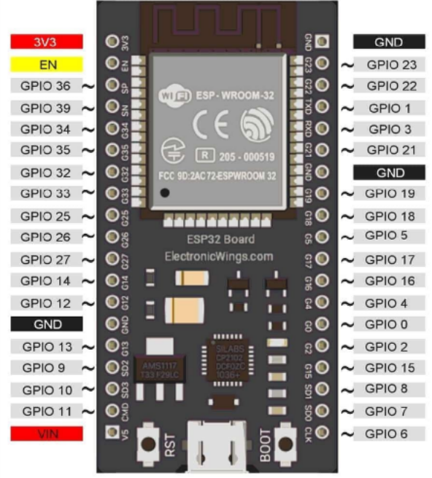

Figure 3.1.1: ESP32

* **MQ2 Gas Sensor:** Detects gases like methane, propane, and smoke. It was selected for its high sensitivity and ability to respond to a wide range of flammable gases, making it suitable for early fire detection.

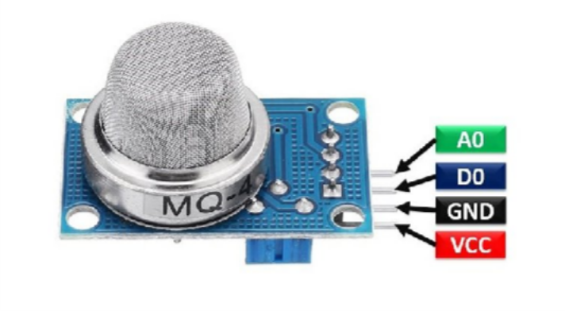

Figure 3.1.2: MQ2 Gas Sensor

* **DHT11 Temperature and Humidity Sensor:** Measures ambient temperature and outputs calibrated digital signals. It was chosen for its simplicity, low power consumption, and reliability in detecting abnormal heat levels associated with fire.

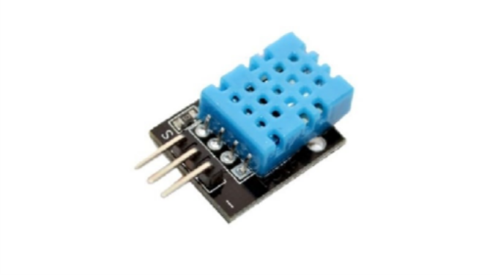

Figure 3.1.3: DHT11

* + **Buzzer:** Produces an audible sound alert when danger is detected. Chosen for its straightforward implementation and ability to immediately notify people in the vicinity

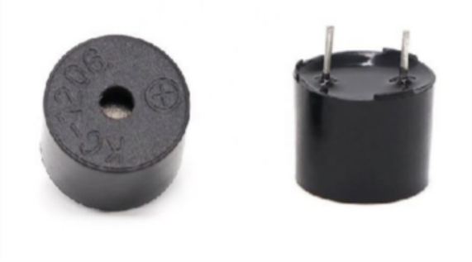

Figure 3.1.4: Buzzer

* + **LEDs:** Provide visual cues for system status (e.g., normal, warning, alert). These were included for easy on-site monitoring, especially in noisy environments.

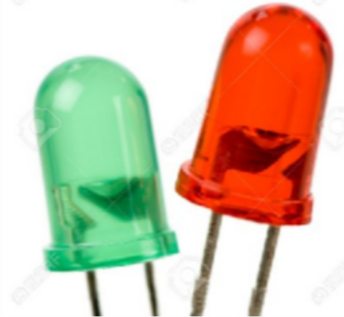

Figure 3.1.5: LEDs

* **Jumper Wires:** Allow temporary circuit assembly without soldering. Chosen for prototyping due to flexibility and reusability.

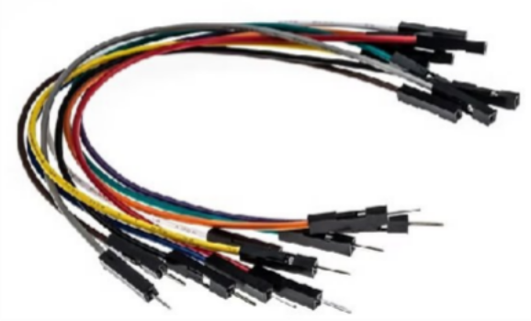

Figure 3.1.6: Jumper Wires

### Software Requirement

The software tools, libraries, and programming environment used in this project were selected for their compatibility with the ESP32 microcontroller and their ability to support real-time IoT functionality.

* **Arduino IDE**: An open-source development environment used to write, compile, and upload code to the ESP32. It was chosen for its simplicity and wide support for sensor libraries and board packages.
* **Blynk IoT Platform**: A cloud-based IoT platform used to create a mobile dashboard for real-time data monitoring and alert notification. Its drag-and-drop interface allowed for rapid mobile app creation without advanced programming.

#### Libraries:

* + **DHT sensor library by Adafruit**: Used for reading temperature data from the DHT11 sensor. This library simplifies communication with the sensor and ensures accurate digital output.
  + **BlynkSimpleEsp32.h**: A critical library that enables the ESP32 to connect to the Blynk cloud server and transmit data to the mobile dashboard.
  + **Custom MQ2 sensor code**: Since the MQ2 provides analog output, a custom logic was implemented to read raw voltage values and interpret gas concentrations relative to a calibrated baseline, using analog-to-digital conversion techniques.
* **Programming Language**: The firmware was written in **C++** using the **Arduino development environment**, which is widely used for embedded system programming. The code structure combines elements of **Embedded C** with object-oriented C++ features to simplify sensor integration and hardware control.
* **Wi-Fi Network**: A stable wireless network was required to enable communication between the ESP32 microcontroller and the Blynk cloud server for remote monitoring.

### Block Diagram

The block diagram provides a high-level conceptual overview of the system's architecture, visually representing its major components and their interconnections. It typically shows the ESP32 as the central processing unit, connected to input modules (MQ2, DHT11 sensors) and output modules (Buzzer, LEDs). A crucial block represents the Wi-Fi communication link to the cloud platform (Blynk Server), which in turn connects to the User's Mobile Application. This diagram clarifies how data flows between different hardware and software blocks.

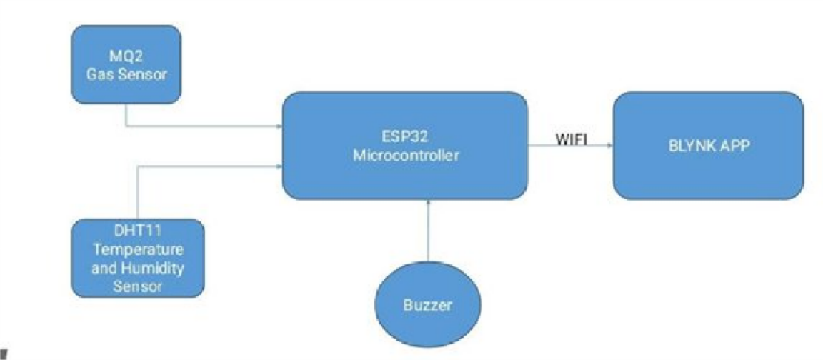

Figure 3.3: Block Diagram

**Algorithm:** The core logic governing the system's behaviour is encapsulated in the following algorithm

#### Step 1: Start the system

**Step2: Initialize all components:**

▫ Start serial communication.

▫ Initialize MQ2 gas sensor.

▫ Initialize DHT11 temperature sensor.

▫ Connect to Wi-Fi and Blynk server.

#### Step3: Continuously perform the following steps:

▫ Read **gas concentration** from MQ2.

▫ Read **temperature** from DHT11.

#### Step4: Compare readings to defined thresholds:

If **gas level > gas threshold AND temperature > temperature threshold**, then: Trigger **buzzer**.

Turn on **red alert LED**.

Send **real-time alert** to Blynk mobile app.

Else:

Keep system in normal state.

Update Blynk dashboard with live sensor data.

**Step5: Repeat the loop after a delay** (e.g., every 2 seconds)

**Step6: End (loop continues indefinitely**

### Hardware Implementation

The physical realization of the system involved meticulous assembly and interconnection of the selected hardware components. Initially, the components were mounted on a breadboard for rapid prototyping, which allowed for flexible testing and modification of the circuit layout. The ESP32's pins were connected to the respective sensors and outputs:

#### ESP32 Microcontroller:

The ESP32-WROOM-32 serves as the central control unit in the system. It features dual-core processing, built-in Wi-Fi and Bluetooth, and a wide array of GPIOs supporting analog, digital, and PWM functionality. Operating at 3.3V, it was responsible for reading sensor inputs, controlling output devices, and transmitting data to the Blynk IoT platform.

* **Total GPIOs**: 38 (usable: approx. 25)
* **Voltage**: 3.3V logic level
* **Special features**: 18 ADC channels, UART, I2C, SPI, PWM
* **Flash memory**: 4MB
* **Operating frequency**: Up to 240 MHz
* **Current consumption**: ~160 mA (active)

#### Pins Utilized in This Project:

* GPIO34: Analog input for MQ2 gas sensor
* GPIO23: Digital I/O for DHT11 sensor
* GPIO4: Digital output for buzzer
* GPIO18: Digital output for green LED
* GPIO19: Digital output for red LED

Unused GPIOs were reserved for potential future expansion or avoided due to boot/flash-related restrictions (e.g., GPIOs 0, 2, 6-11).

#### MQ2 Sensor:

* **Function**: Detects flammable gases like methane, LPG, hydrogen, and smoke.
* **Working Principle**: The sensor contains a heating element and a sensitive layer (tin dioxide). In the presence of gases, resistance changes, resulting in a measurable change in output voltage.

#### Technical Specs:

* + Operating Voltage: 3.3V–5V
  + Output: Analog voltage (AO), optionally digital (not used)
  + Sensitivity: 200 ppm to 10000 ppm (depending on gas type)
  + Preheat Time: ~20 seconds (min), ~60 seconds for stability
  + Detection Range: ~300–4000 ppm for LPG and methane

#### Connections:

* VCC → 3.3V
* GND → GND
* AO → GPIO34

**Justification for Assigning GPIO34**: GPIO34 is an **ADC-enabled input-only pin**, ideal for safely capturing analog data from sensors. It is not involved in boot or flash processes, ensuring clean voltage readings from the MQ2 sensor.

**Threshold Value Set**: The threshold for gas concentration was set to **400 ppm**. This value represents a moderate presence of combustible gases and helps ensure timely detection of fire risk while minimizing false positives from routine activities such as cooking.

#### DHT11 Sensor:

* **Function**: Measures ambient temperature and humidity
* **Working Principle**: Uses a thermistor and capacitive humidity sensor. The sensor transmits a digital signal encoding temperature and humidity values.

#### Technical Specs:

* + Operating Voltage: 3.3V–5V
  + Output: Digital (single-wire communication)
  + Temperature Range: 0°C to 50°C (Accuracy: ±2°C)
  + Humidity Range: 20–90% RH (Accuracy: ±5% RH)
  + Sampling Rate: 1 Hz (one reading per second)

#### Connections:

* VCC → 3.3V
* GND → GND
* DATA → GPIO23 (with 10kΩ pull-up resistor)

**Justification for Assigning GPIO23**: GPIO23 is a stable **digital I/O pin** with no reserved system functions, making it suitable for the timing-sensitive single-wire protocol of the DHT11 sensor.

**Threshold Value Set**: The temperature threshold was defined as 38**°C**, a level that exceeds typical indoor conditions and serves as a reliable indicator of elevated thermal risk. Although the sensor also captures humidity, this parameter was not used in the alerting logic for this version of the prototype but remains available for future system enhancements or adaptive logic adjustments.

#### Buzzer:

* **Function**: Provides audible alert during fire condition
* **Working Principle**: When a voltage is applied, the internal piezoelectric element vibrates to produce sound.

#### Technical Specs:

* + Operating Voltage: 3.3V–5V
  + Frequency Range: 2 kHz–4 kHz (typical)
  + Current Consumption: ~10 mA
  + Control: Digital HIGH signal

#### Connections:

* Positive terminal → GPIO4
* Negative terminal → GND

**Justification for Assigning GPIO4**: GPIO4 is a **digital output-capable pin**, capable of driving low-current actuators such as a buzzer. Its location and availability made it optimal for signal control.

#### LED Indicators

* **Function**: Indicate system status visually:
  + Green: Normal
  + Red: Alert (both sensors triggered)
* **Working Principle**: LEDs emit light when forward-biased current flows through them.

#### Technical Specs:

* + Forward Voltage: ~2V
  + Forward Current: 10–20 mA
  + Connected through 220Ω resistors to limit current

#### Connections:

* Green LED → GPIO18
* Red LED → GPIO19

**Justification for Assigning GPIO18and GPIO19**: These GPIOs are **digital output pins** that are free from system-critical constraints. Their stable behavior and physical location on the board made them ideal choices for driving indicator LEDs.

#### Breadboard and Jumper Wires

To facilitate a modular and easily modifiable prototype, all components were interconnected using a **solderless breadboard** (later transitioned to a soldered PCB version to enhance durability and ensure a permanent, stable connection for final demonstration) and **jumper wires**. The breadboard allows temporary circuit construction without the need for soldering, making it ideal for testing and debugging. Jumper wires provide flexible connectivity between ESP32 GPIO pins and peripheral components. Their reusability and simplicity reduce wiring complexity and enable quick reconfiguration during the development phase.

This assembly method ensured clean signal routing, simplified fault tracing, and maintained an organized layout suitable for demonstration and future scalability.

Table 2: Summary of ESP32 Pin Assignments

|  |  |  |  |
| --- | --- | --- | --- |
| **Component** | **ESP32 Pin** | **Pin Type** | **Purpose** |
| MQ2 Gas Sensor | GPIO34 | Analog Input | Read analog voltage based on gas level |
| DHT11 Sensor | GPIO23 | Digital I/O | Single-wire data communication |
| Buzzer | GPIO4 | Digital Output | Trigger sound alert |
| Green LED | GPIO18 | Digital Output | Indicate normal status |
| Red LED | GPIO19 | Digital Output | Indicate fire alert |

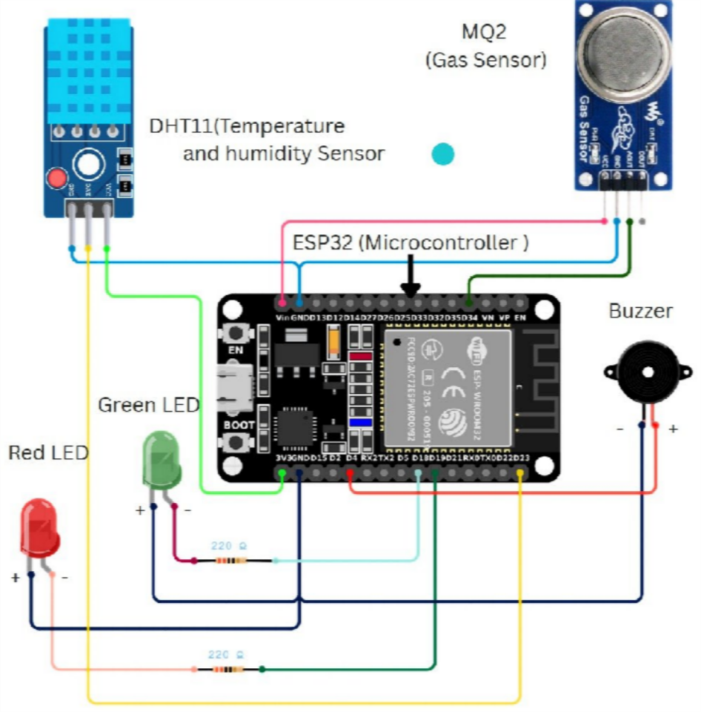

Figure 3.4.1: Circuit Pin Connection Diagram

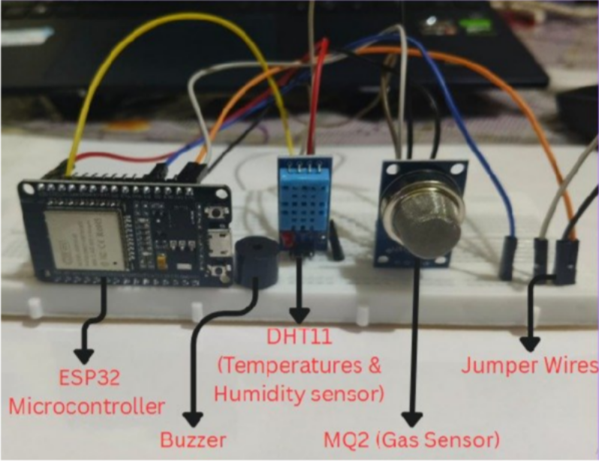

Figure 3.4.2: Prototype Circuit Overview

### Software Implementation

The software implementation phase focused on developing the logic that enables real-time monitoring, alerting, and communication between the ESP32 microcontroller, sensors, and the Blynk IoT platform. This was achieved by writing custom firmware using the Arduino IDE, integrating appropriate libraries, and configuring wireless connectivity.

#### Programming Environment

* **IDE Used**: Arduino IDE
* **Language**: C++ (within the Arduino framework)
* **Target Board**: ESP32 Dev Module

The Arduino IDE was chosen for its extensive library support and compatibility with ESP32. The firmware was written in C++, making use of modular functions for sensor reading, data validation, and communication with the Blynk interface.

The full Arduino firmware for the system, including sensor handling, threshold logic, and Blynk integration, is publicly available on GitHub *[9]*. Key implementation aspects are discussed below using relevant snippets and detailed explanations.

#### Key Libraries Used

* **DHT sensor library (by Adafruit*[10]*)**: Used for initializing and communicating with the DHT11 sensor to capture ambient temperature and humidity data.
* **BlynkSimpleEsp32.h**: Enables ESP32 to communicate with the Blynk mobile application and update real-time values on virtual pins.
* **WiFi.h**: Handles network connectivity so that ESP32 can join the local Wi-Fi network and enable Blynk access.

Custom logic was developed to convert analog output from the MQ2 gas sensor to a scaled value representing gas concentration levels. This was compared against a pre-set threshold for fire risk assessment.

**Programming Workflow with Code Snippets and Parameter Explanations**

1. **Initialization**:
   1. **Define Thresholds**:

const int GAS_THRESHOLD = 400;

// Dangerous gas level in ppm

const float TEMP_THRESHOLD = 38.0; // High temperature threshold (°C)

const float HUMIDITY_LOW_THRESHOLD = 10; // Optional lower limit for humidity

Figure 3.5.1: Code Snippet 1

These parameters were determined through reference values and testing. A gas concentration above 400 ppm is considered hazardous, and 38°C is above normal indoor temperature, indicating fire risk. A humidity threshold was considered for future adaptability but not used in alert logic.

#### Wi-Fi and Blynk Setup:

char ssid[] = "YourNetworkName"; char pass[] = "YourPassword";

#define BLYNK_AUTH_TOKEN "YourAuthToken"

Figure 3.5.2: Code Snippet 2

These parameters are user-specific. The ESP32 uses them to connect to Wi-Fi and authenticate with the Blynk platform.

#### Sensor Data Acquisition:

* 1. Reading sensor values:

int gasValue = analogRead(MQ2_PIN); // MQ2 returns analog voltage based on gas levels float temperature = dht.readTemperature(); // DHT11 returns temperature in °C

float humidity = dht.readHumidity(); // DHT11 returns humidity in %

Figure 3.5.3: Code Snippet 3

The gas sensor's analog signal indicates gas concentration. DHT11 provides both temperature and humidity, used for monitoring and validation.

#### Decision Logic:

* 1. Triggering alerts when thresholds are crossed:

if (gasValue > GAS_THRESHOLD && temperature > TEMP_THRESHOLD) { digitalWrite(BUZZER_PIN, HIGH);

digitalWrite(RED_LED_PIN, HIGH);

}

Figure 3.5.4: Code Snippet 4

Only when **both** gas and temperature exceed safe limits does the system activate the buzzer and red LED. This dual-condition helps minimize false positives.

#### Sensor Health Monitoring:

* 1. Ensuring sensors return valid values:

if (isnan(temperature) || isnan(humidity)) { Blynk.virtualWrite(V3, "❌ FAIL");

} else {

Blynk.virtualWrite(V3, "✅ OK");

}

Figure 3.5.5: Code Snippet 5

If the DHT sensor fails to return usable values, a health status is displayed in the app. A similar method is applied to the MQ2 gas sensor.

#### Blynk Integration:

* 1. Transmitting live sensor data to the app:

|  |  |  |  |
| --- | --- | --- | --- |
| Blynk.virtualWrite(V0, temperature); | // | Temperature | reading |
| Blynk.virtualWrite(V1, humidity); |  | // Humidity | level |
| Blynk.virtualWrite(V2, gasValue); // Gas concentration |  |  |  |

Figure 3.5.6: Code Snippet 6

Virtual pins on Blynk allow real-time display of sensor data to the user. Each sensor is mapped to a virtual pin.

#### Timer Execution:

* 1. Scheduling periodic data collection:

timer.setInterval(2000L, sendSensorData);

Figure 3.5.7: Code Snippet 7

The Blynk timer runs sendSensorData() every 2 seconds to check and update readings without blocking the loop.

#### Wi-Fi Status Indication:

* 1. LED feedback for connection status:

if (WiFi.status() == WL_CONNECTED) { digitalWrite(GREEN_LED_PIN, HIGH); // Wi-Fi connected

} else {

digitalWrite(GREEN_LED_PIN, millis() / 500 % 2); // Blinking if disconnected

}

Figure 3.5.8: Code Snippet 8

The green LED remains ON when Wi-Fi is active, or blinks when disconnected, helping users diagnose connectivity issues quickly.

#### Wi-Fi and Blynk Conneceivity

The ESP32 connects to a local Wi-Fi network using credentials provided in the code. It communicates directly with the Blynk mobile application via the Blynk platform to send real-time sensor data and receive user control inputs. Although Blynk provides a cloud-based interface, this project uses only its basic dashboard functionality for remote mobile access, and no cloud data storage or analytics features are integrated.

This software architecture ensures that the system is responsive, scalable, and capable of providing accurate, dual-validated alerts in real time. Each parameter was chosen based on safety standards and sensor specifications. The modular structure of the codebase makes it extensible for future enhancements such as external alarms, GPS modules, or cloud logging systems.

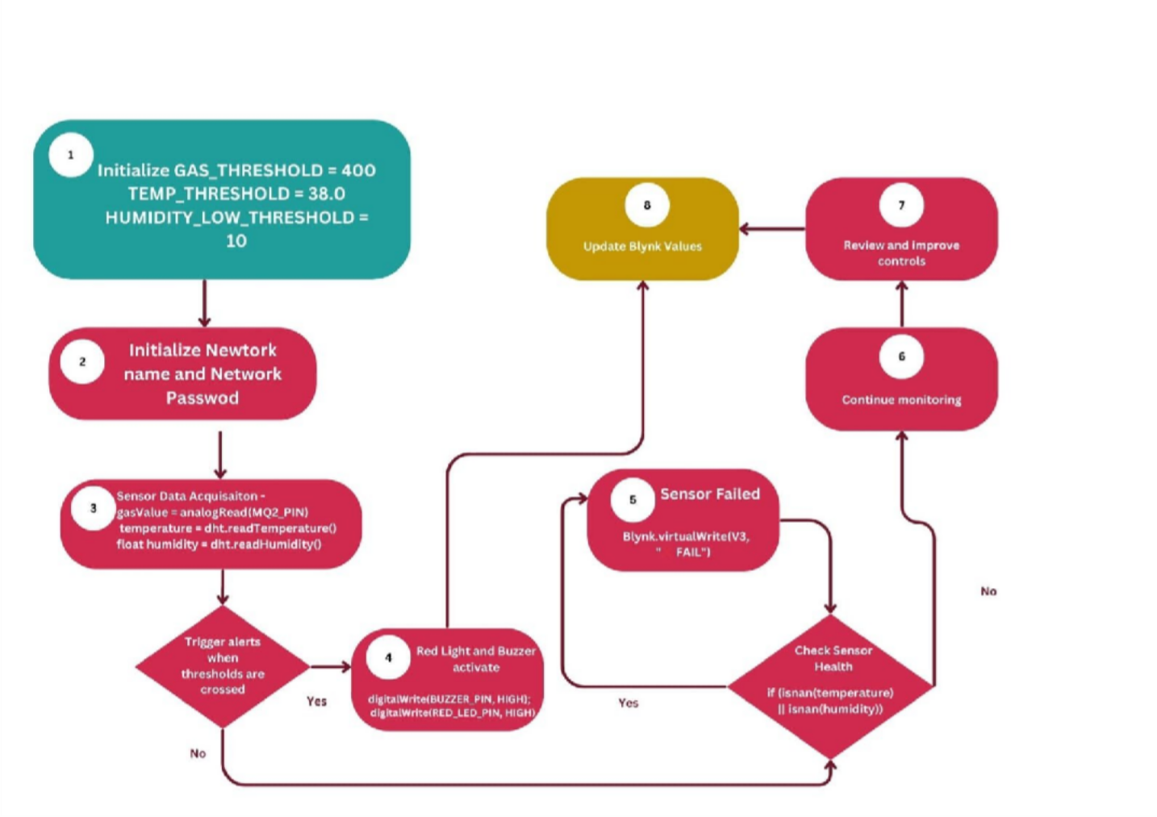

Figure 3.6: Flow Diagram

CHAPTER 4 RESULTS AND DISCUSSION

## CHAPTER 4

RESULTS AND DISCUSSIONS

#### Results and Observations

The IoT-based fire detection system prototype was subjected to multiple test scenarios in a controlled indoor environment to evaluate its effectiveness, accuracy, and real-time responsiveness. Each test was designed to simulate specific environmental changes — such as elevated temperature, the presence of flammable gas, or sensor disconnection — to validate whether the system could reliably identify risks and generate appropriate alerts.

Key observations from the testing phase are as follows:

* + - The system reliably triggered an alert only when both temperature exceeded **38°C** and gas concentration crossed **400 ppm**, confirming correct implementation of dual-threshold logic.
    - Individual threshold breaches (temperature-only or gas-only) did not trigger false alerts, demonstrating proper condition validation.
    - Upon detecting a fire-like condition, the **buzzer** and **red LED** were activated instantly, while notifications were simultaneously sent via the **Blynk mobile application**.
    - Sensor disconnection or malfunction was accurately detected. In such cases, Blynk virtual pins V3 and V4 displayed a "❌ FAIL" status, providing clear diagnostics.
    - Wi-Fi connectivity was continuously monitored. The **green LED** indicated connection status accurately, remaining **ON** when connected and **blinking** when disconnected.
    - Sensor data (temperature, humidity, gas concentration) was updated on Blynk every two seconds without noticeable lag, enabling consistent remote monitoring.

These observations confirm that the prototype behaves as intended and provides a functional, low-cost solution suitable for real-time fire detection in indoor environments.

### Test Cases

Each major system function was tested under realistic conditions to ensure correct performance. The following sections describe the system behavior for individual test cases in detail:

#### Test Case 1: Combined Threshold Breach (Fire Condition)

* + - **Input**: A heat source was used to raise the temperature above 38°C while the gas sensor was stimulated using a source such as a butane lighter to increase gas concentration above 400 ppm.
    - **Expected Output**: Buzzer ON, Red LED ON, fire alert pushed to Blynk, and email notification sent.
    - **Observation**: System successfully identified this as a fire condition, activated alerts, and sent dual log events to the Blynk app along with an email notification.

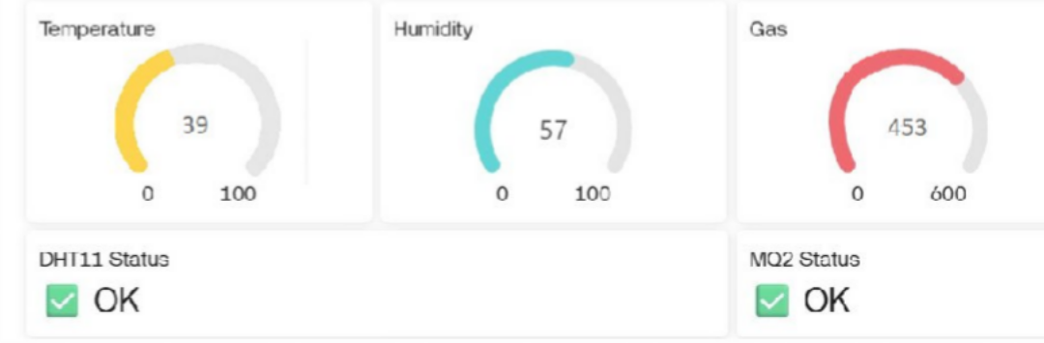

Figure 4.2.1: Threshold Condiotions Met

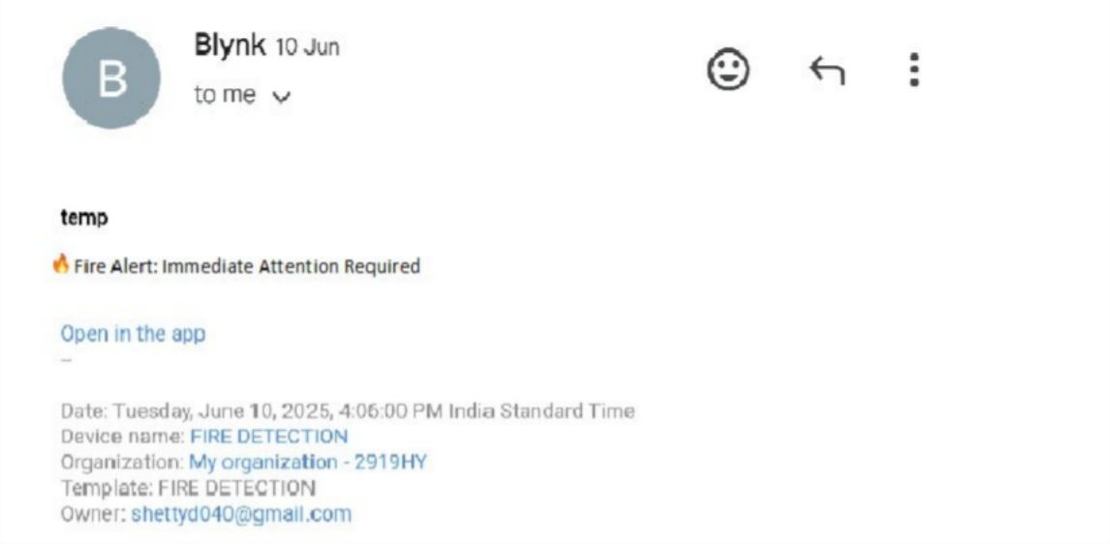

Figure 4.2.2: Email Notification when Fire is Detected

#### Test Case 2: DHT11 Sensor Disconnection

* + - * **Input**: The DHT11 sensor’s data pin was manually disconnected during active monitoring to simulate a hardware fault.
      * **Expected Output**: The system should detect the sensor failure, display “❌ FAIL” on Blynk virtual pin V3, and send an email alert regarding the DHT11 malfunction.
      * **Observation**: The system successfully identified the disconnection. Blynk displayed a “❌

FAIL” status under sensor health for V3, and a corresponding email notification was triggered. Other parts of the system continued functioning normally.

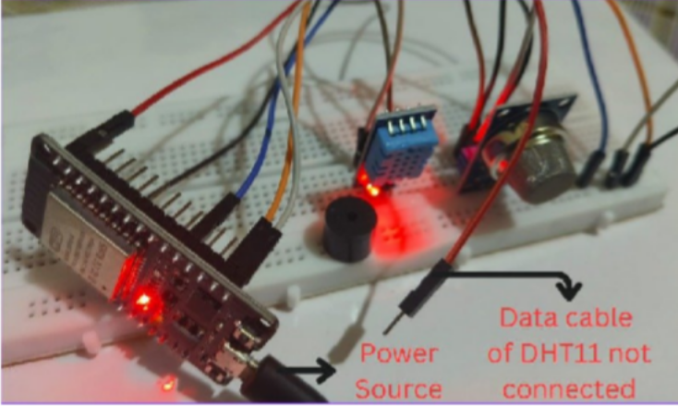

Figure 4.2.3: DHT11 Sensor not Connected

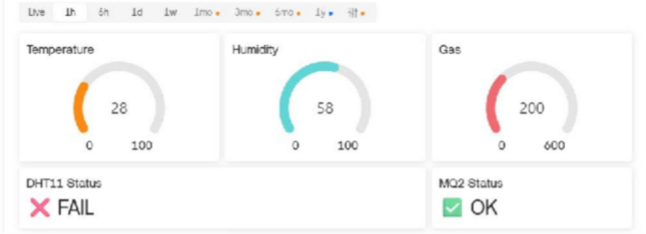

Figure 4.2.4: Blynk Dashboard upon disconnecting DHT11 Sensor

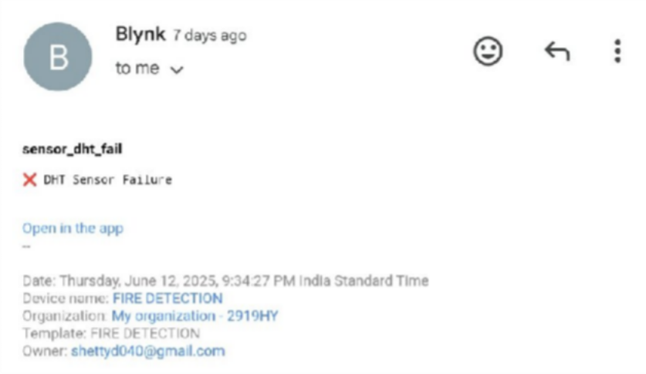

Figure 4.2.5: Email sent upon disconnecting DHT11 Sensor

#### Test Case 3: MQ2 Sensor Out-of-Range Condition

* + - **Input**: The MQ2 sensor was made to produce out-of-range values (e.g., by introducing a loose connection resulting in readings < 50 or > 4090).
    - **Expected Output**: "FAIL" status should appear on Blynk (V4), with an accompanying email alert.
    - **Observation**: The system successfully detected abnormal MQ2 readings, displayed a sensor failure message on V4, and triggered an email notification.
    - **Input**: DHT11 was physically disconnected, and MQ2 was made to produce out-of-range values (below 50 or above 4090).
    - **Expected Output**: “FAIL” status on Blynk (V3 or V4), and email notification.
    - **Observation**: Sensor issues were promptly detected. Blynk displayed error messages and sent an email alert regarding sensor malfunction.

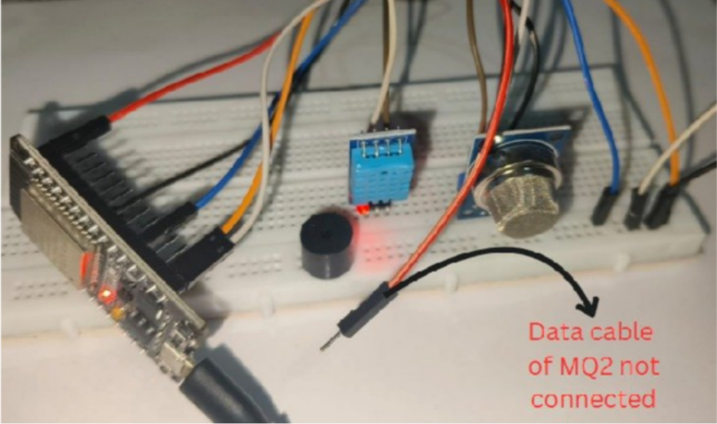

Figure 4.2.6: MQ2 Sensor not Connected

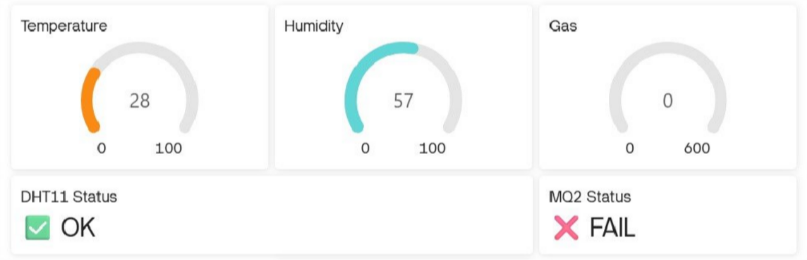

Figure 4.2.7: Blynk Dashboard upon disconnecting MQ2 Sensor

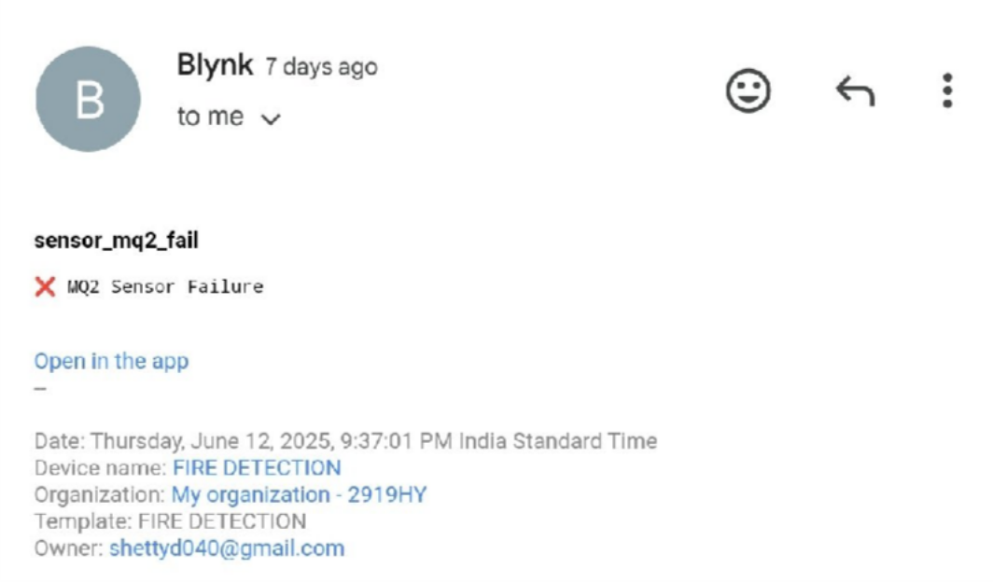

Figure 4.2.8: Email sent upon disconnecting DHT11 Sensor

#### Test Case 4: Wi-Fi Disconnection

* + - **Input**: Router was turned off briefly during runtime.
    - **Expected Output**: Green LED should blink, and no data sent to Blynk until reconnection.
    - **Observation**: Green LED blinked during disconnection. Data transmission resumed automatically once Wi-Fi was restored. No email alert was triggered, as this condition was not set to raise one.

#### Test Case 5: Normal Monitoring State

* + - **Input**: No fire or gas hazard simulated. All values within safe range.
    - **Expected Output**: No alerts; continuous Blynk updates.
    - **Observation**: System continued to log temperature, humidity, and gas data accurately every 2 seconds. No false triggers or unnecessary alerts were sent.

#### Test Case 6: Single Threshold Breach (Only Temp or Only Gas)

* + - **Input**: In one case, hot air was directed at the DHT11 sensor to raise temperature > 38°C. In the other, gas fumes were directed to increase concentration > 400 ppm individually.
    - **Expected Output**: No alert, as dual-threshold condition is not satisfied.
    - **Observation**: No buzzer or LED was triggered, no alert pushed to Blynk or email sent. The system accurately recorded data without false alerts.

.

### Analysis of Results

The prototype’s test results clearly demonstrate that the dual-threshold logic effectively eliminates false positives by ensuring both gas and temperature conditions are met before triggering alerts. This provides greater reliability in high-sensitivity environments like educational institutions.

The system's ability to detect disconnected or faulty sensors ensures continuous diagnostics, which is critical for long-term deployment. By sending error updates to the Blynk platform and pushing email alerts, users are made aware of potential failures in real time.

Additionally, the seamless Wi-Fi monitoring through LED indication and automatic reconnection enhances user trust and system usability. Regular updates of environmental data every 2 seconds without noticeable lag further validate the microcontroller's responsiveness.

No unexpected behaviors or false alerts were encountered during testing. Alerts were consistent with pre- defined logic and were appropriately communicated to the user via the mobile application and email. These results reinforce the reliability, low latency, and practical feasibility of the proposed system for low-cost fire detection and alerting applications.

### Performance Analysis

The rigorous testing and operational observation of the system yielded compelling evidence of its robust performance across several key metrics:

**Response Time**: The system exhibited a detection and alert generation capability with a response time of approximately 10 seconds after fire conditions were simulated. This estimation is based on observed delay from threshold breach to activation of the buzzer and mobile notification, and while not instrumented with precise timing tools, it remained consistent across multiple trials.

**Accuracy and False Alarm Reduction**: By enforcing a dual-threshold logic requiring both elevated gas concentration and temperature, the system effectively filtered out isolated environmental anomalies. This multi-sensor validation reduced the likelihood of false alarms that may occur with single-parameter detection systems (e.g., heat from cooking or non-flammable smoke).

**Reliability**: Throughout extended testing sessions, the system demonstrated stable and uninterrupted performance. All expected alerts were consistently triggered, and real-time sensor data was transmitted to the Blynk platform with no packet loss or lag beyond the predefined 2-second interval.

**Scalability**: The architecture allows for simple horizontal expansion. Additional ESP32 nodes can be deployed across multiple rooms or zones, each configured to communicate with a shared Blynk project. This eliminates the need for extensive rewiring or complex integration logic, making the system suitable for modular upgrades in institutions of varying size.

CHAPTER 5 CONCLUSION AND FUTURE SCOPE

## CHAPTER 5

CONCLUSION AND FUTURE SCOPE

This project successfully demonstrated the feasibility and effectiveness of a smart fire detection system using IoT technology. By integrating the ESP32 microcontroller with MQ2 and DHT11 sensors, the system was able to detect hazardous environmental conditions such as high temperature and gas concentration with a high degree of accuracy. The use of dual-condition logic significantly reduced false alarms and increased system reliability.

The Blynk platform enabled real-time notifications to users, even when they were off-site, ensuring that potential fire hazards could be addressed promptly. Local alerts via the buzzer added another layer of safety by immediately notifying nearby individuals. The system’s affordability and scalability make it a practical solution for enhancing fire safety in educational institutions, hostels, and small public infrastructures.

This project also emphasized the importance of user-centered design through the application of design thinking principles. By engaging with actual users during the research phase, the team ensured that the system addressed genuine safety concerns and usability expectations.

#### Future Scope

While the current prototype fulfills the foundational objectives, several enhancements can be explored in future iterations:

* Integration of additional environmental sensors (e.g., flame sensors, CO sensors) to improve detection precision.
* Implementation of GSM-based fallback alert mechanisms for use in Wi-Fi-constrained environments.
* Development of a centralized web dashboard for monitoring multiple ESP32 units across large campuses.
* Use of AI or ML models to analyze sensor patterns for predictive fire risk detection.
* Incorporation of evacuation route guidance or audio-visual emergency instructions in case of alert triggers.

CHAPTER 6

OUR JOURNEY EXPERIENCE AND TAKE AWAY

## CHAPTER 6

OUR JOURNEY EXPERIENCE AND TAKEAWAY

### AS A TEAM -

The team’s innovation journey began in Semester 1 with the Innovation and Design Thinking (IDT) course, which introduced the foundational principles of user-centered problem solving. Under the guidance of Dr. Roopa R. Kulkarni, the team was encouraged to explore real-world challenges and understand how empathy, observation, and ideation drive effective innovation.

During this phase, the team engaged in field research, stakeholder interviews, and design thinking exercises to identify gaps in campus safety. This exploration led to the formulation of the problem statement that later evolved into a working prototype. IDT provided the space to think beyond conventional boundaries, challenge assumptions, and work collaboratively through ideation techniques like mind mapping, persona building, and 5W+1H analysis.

In Semester 2, through the Engineering Exploration Course (EEC), the team transitioned from conceptual thinking to hands-on implementation. This course enabled the transformation of ideas into a tangible, working IoT-based fire detection prototype. Here, the focus shifted to technical exploration, system integration, and iterative testing. The knowledge gained during IDT was applied in a practical context, reinforcing the connection between design intent and functional output.

Throughout both semesters, the team's skills matured in multiple dimensions — ideation, teamwork, prototyping, documentation, and real-world validation. The mentorship of Dr. Roopa R. Kulkarni remained instrumental throughout, ensuring structured progression while allowing creative freedom.



### INDICIDUAL LEARNING EXPERIENCE -

#### Vineet K V(1DT24IC049) –

Serving as the team leader for this project was both challenging and rewarding. It offered exposure to the full project lifecycle—from ideation and planning to execution and testing—while balancing technical and managerial responsibilities.Leadership involved coordinating the team’s efforts, distributing tasks, and ensuring timely progress. This strengthened key skills such as communication, decision-making, and adaptability, especially when facing unexpected challenges.During the IDT (Innovation and Design Thinking) phase, my role centered on guiding the

team through problem definition, stakeholder analysis, and brainstorming. Facilitating these sessions helped me encourage creativity while maintaining structure and direction.

In the EEC (Engineering Exploration Course) phase, the focus shifted to practical implementation. Leading the hardware setup and testing process enhanced my understanding of ESP32 integration, sensor logic, and IoT communication. Managing the team through debugging and refinement cycles required persistence and clarity under pressure.This experience also offered valuable insight into real- world project dynamics—how concepts evolve into solutions through teamwork, iteration, and user- centered design. Keeping team motivation high during trial-and-error phases was key to our progress. Guidance from Dr. Roopa R. Kulkarni was pivotal throughout. Her mentorship emphasized empathy, structure, and design thinking, shaping my approach to leadership and collaboration.

Overall, the experience helped me grow as both an engineer and a leader, building a strong foundation for future roles in multidisciplinary projects and innovation-driven environments.

#### Adithya D Shetty (1DT24IC002) –

Participating in this project gave me an excellent opportunity to explore the integration of embedded systems with IoT platforms for real-time problem-solving. Before this, I had only basic experience with microcontrollers, but this project allowed me to become confident with ESP32 programming, sensor interfacing, and real-time debugging. One of the most valuable skills I developed was translating user needs into technical logic. Through surveys and design thinking activities, I learned how to analyze problems from a user-centric perspective and engineer solutions that are both

functional and practical. I also contributed significantly to the mobile app interface and sensor testing

phases, ensuring that the system was user-friendly and stable under realworld conditions. Beyond technical skills, I developed a deeper appreciation for structured teamwork, project documentation, and time-bound execution. The challenges we faced taught me resilience and creative problem- solving—skills I now carry with confidence into future academic and professional pursuits.

#### Samiksha Singi (1DT24IC034)-

I, Samiskhsa Singi, was a part of a student team working on an IoT-based fire detection prototype as part of the Innovation and Design Thinking (IDT) course in Semester 1 and the Engineering Exploration Course (EEC) in Semester 2, under the mentorship of Dr. Roopa R. Kulkarni.

My role in the team focused on documentation and Blynk setup. I was responsible for organizing our ideas, maintaining clarity in our reports, and ensuring that all technical details

were well-communicated. I also worked on configuring the Blynk IoT platform, which allowed us to monitor sensor data in real-time and receive alerts during simulated fire conditions.

Through IDT, I developed a deeper understanding of empathy-driven innovation and the importance of designing for real user needs. In EEC, I gained hands-on exposure to IoT tools and strengthened my ability to translate theoretical knowledge into a working solution.

This journey taught me how to collaborate effectively, manage responsibilities, and think creatively under constraints. It has greatly enhanced my confidence and skills as an engineering student.

#### Jyoshita N H (1DT24IC015) -



conditions.

As a member of the student team developing an IoT-based fire detection prototype under the mentorship of Dr. Roopa

R. Kulkarni, I have played a key role in documentation and testing during the Innovation and Design Thinking (IDT) course in Semester 1 and the Engineering Exploration Course (EEC) in Semester 2. This role allowed me to strengthen both technical and analytical skills, particularly in systematically verifying system functionality, analyzing sensor outputs, and ensuring reliability under different

I was also responsible for clearly documenting the design process, test results, and iterations, which enhanced my technical writing and communication abilities. One of the main challenges faced was identifying intermittent issues during prototype testing, which required patience, precision, and collaborative troubleshooting. The IDT phase fostered a spirit of innovation and idea refinement, while the EEC phase emphasized implementation, rigorous testing, and teamwork.

Through this journey I developed a deeper appreciation for structured engineering processes, the importance of clear communication within teams, and the iterative nature of real-world problem- solving. The experience contributed significantly to [his/her/their] growth in innovation, engineering thinking, and collaborative project execution.

### Key Takeaways -

The team derived several important takeaways from the combined learning experience:

* + Empathy-Driven Problem Solving:

The importance of understanding user needs before proposing solutions was deeply emphasized during the IDT course. This mindset influenced every stage of project development.

* + Collaborative Learning:

Working in a team setting allowed each member to bring unique perspectives and strengths. It also highlighted the value of coordination, active listening, and mutual respect during ideation and development.

* + Iterative Thinking:

Prototyping and testing under EEC encouraged an iterative approach—improving the design with each feedback cycle. This helped the team appreciate the role of experimentation in engineering.

* + Practical Application of Engineering Skills:

EEC provided hands-on exposure to microcontrollers, sensors, circuit design, and software integration, bridging the gap between theory and practice.

* + Design to Deployment Perspective:

The combined curriculum instilled an understanding of how products move from user problems to validated solutions, emphasizing not just building, but building with purpose.

#### Faculty Mentorship:

The consistent guidance and encouragement from Dr. Roopa R. Kulkarni created a structured yet explorative environment where curiosity, creativity, and technical growth were nurtured.

# REFERENCE

#### Research Papers (IEEE Format)

1. I. M. Al Shereiqi and M. Sohail, “Smart Fire Alarm System Using IoT,” *4th Middle East College Student Research Conference*, Muscat, Oman, 2019. [Online]. Available: <https://www.researchgate.net/publication/347130865>
2. K. Kumar and V. K. Pau, “Significance of Fire Protection System Reliability for Structure Fire Safety,” *Structural Engineering Digest*, vol. 2, no. 1, pp. 12–18, 2022. [Online]. Available: <https://www.researchgate.net/publication/367981356>
3. M. Xu and D. Peng, “PyroSim-Based Numerical Simulation of Fire Safety and Evacuation Behaviour of College Buildings,” *International Journal of Safety and Security Engineering*, vol. 10, no. 3, pp. 256–269, 2020. [Online]. Available: <https://www.researchgate.net/publication/341570155>
4. F. Zahmatkesh and A. M. Memari, “Review of Conventional and Innovative Technologies for Fire Retrofitting of Existing Buildings,” *Open Journal of Civil Engineering*, vol. 7, pp. 251–269, 2017. [Online]. Available: <https://www.researchgate.net/publication/317381142>
5. G. Alfalah et al., “Development of Fire Safety Assessment Model for Buildings Using Analytic Hierarchy Process,” *Applied Sciences*, vol. 13, no. 7, pp. 1–19, 2023. [Online]. Available: <https://www.researchgate.net/publication/371957645>
6. R. P. Singh, “A Brief Study on Alarm System of Fire,” *International Journal of Innovative Research in Computer Science & Technology (IJIRCST)*, vol. 10, no. 3, pp. 129–132, 2022. [Online]. Available: <https://journals.acspublisher.com/index.php/ijircst/article/view/10604>
7. V. Kodur, P. Kumar, and M. M. Rafi, “Fire Hazard in Buildings: Review, Assessment, and Strategies for Improving Fire Safety,” *PSU Research Review*, vol. 4, no. 1, pp. 78–92, 2020. [Online]. Available: <https://www.researchgate.net/publication/336052262>
8. T. Eremina and D. Korolchenko, “Fire Protection of Building Constructions with the Use of Fire- Retardant Intumescent Compositions,” *Moscow State University of Civil Engineering*, 2020. [Online]. Available: <https://www.researchgate.net/publication/346243050>

#### Hardware & Tools Documentation

1. Adafruit Industries, “DHT Sensor Library,” GitHub, [Online]. Available: <https://github.com/adafruit/DHT-sensor-library>
2. Blynk IoT Platform. [Online]. Available: [https://blynk.io](https://blynk.io/)
3. Arduino IDE. [Online]. Available: <https://www.arduino.cc/en/software>
4. Espressif Systems, “ESP32-WROOM-32 Datasheet,” [Online]. Available: <https://www.espressif.com/sites/default/files/documentation/esp32_datasheet_en.pdf>
5. Hanwei Electronics, “MQ-2 Gas Sensor Datasheet,” [Online]. Available: <https://www.sparkfun.com/datasheets/Sensors/Biometric/MQ-2.pdf>
6. Aosong Electronics, “DHT11 Temperature & Humidity Sensor Datasheet,” [Online]. Available: <https://www.mouser.com/datasheet/2/758/DHT11-Technical-Data-Sheet-1152473.pdf>

#### Software & Design Tools

1. GitHub Repository – IoT-Based Fire Detection System. *Available at:* - <https://github.com/vineetkonefour/fire-detection-iot/blob/main/fire_alert.ino>
2. XMind – Mind Mapping Tool. [Online]. Available: <https://xmind.app/>
3. Canva – Online Design Platform. [Online]. Available: <https://www.canva.com/>

#### Images

1. https://images.app.goo.gl/62FzXYSi1dM6Fn8U6
2. <https://images.app.goo.gl/pDz9aTwJtHzYazwt9>

#### C. Institutional References

1. Sharada Shri School – Project application site.
2. Dayananda Sagar Academy of Technology and Management – Academic Institution

# ANNEXURE I

Table 2:Research Paper Summary

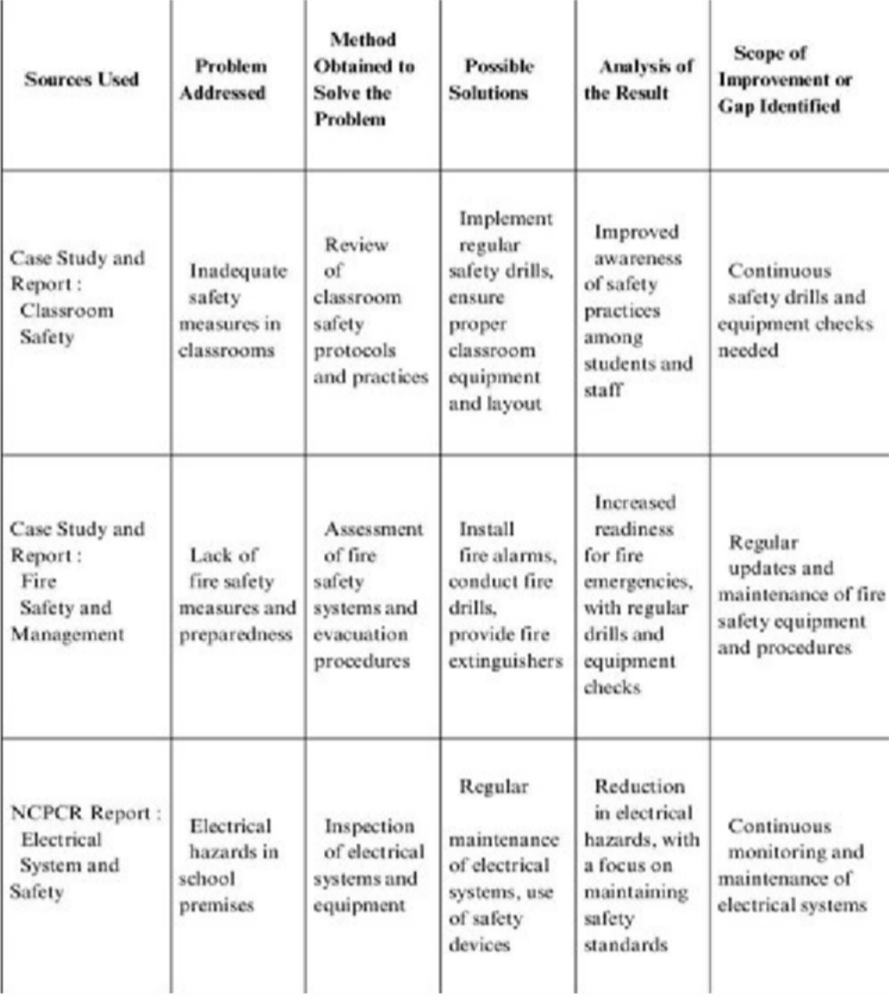

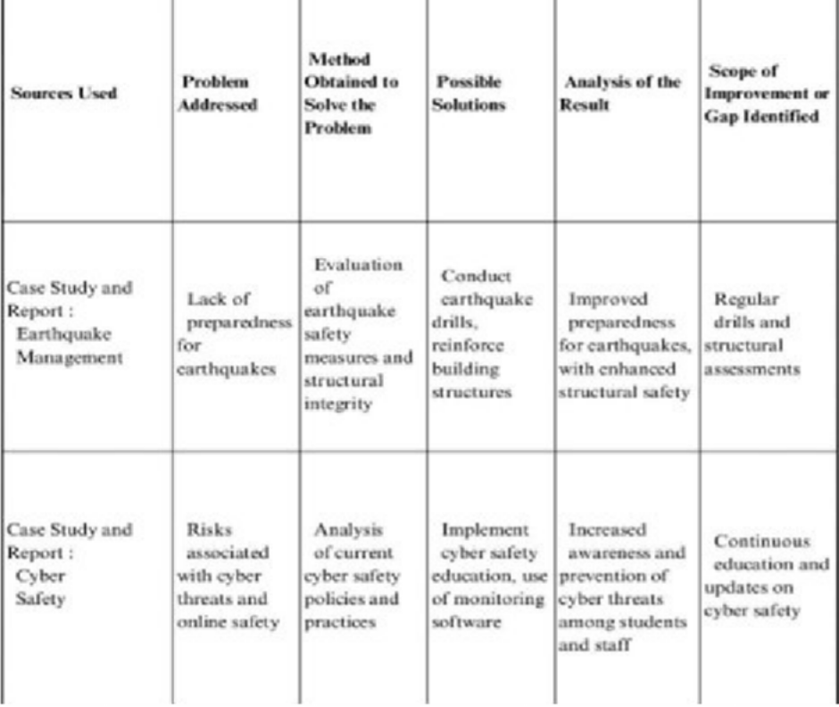

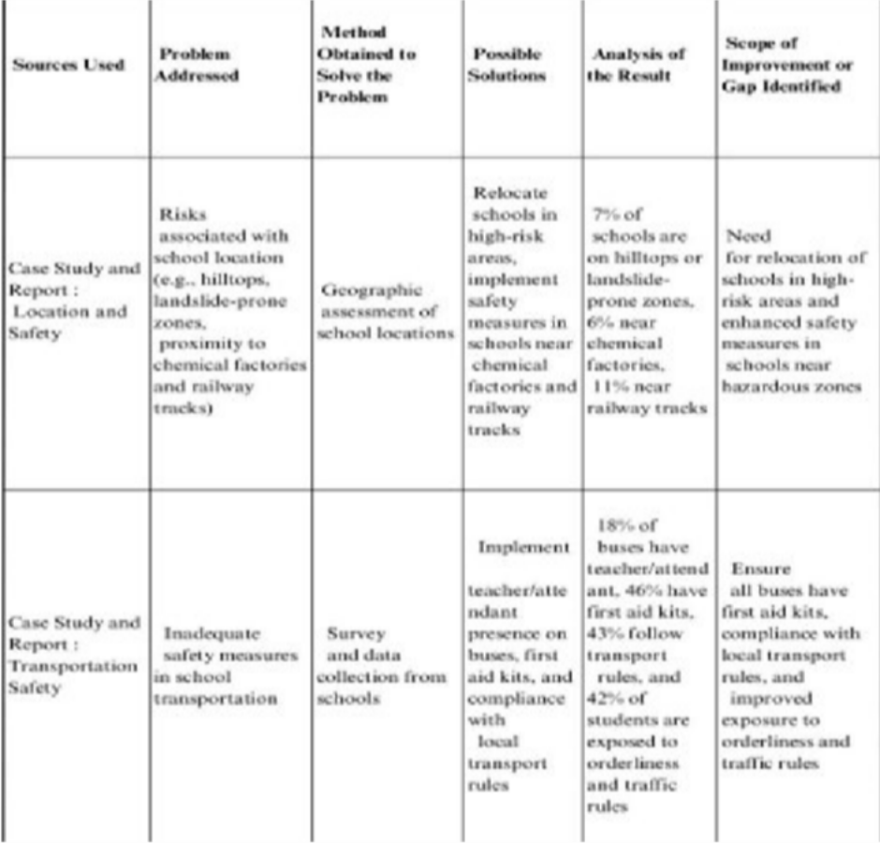

### Datasheets of the Hardware Components

Table 3: ESP32 Microcontroller Datasheet [12]

|  |  |
| --- | --- |
| **Parameter** | **Specification** |
| Microcontroller | Tensilica Xtensa® 32-bit LX6 dual-core |
| Clock Speed | Up to 240 MHz |
| Flash Memory | 4 MB (typical for WROOM-32 module) |
| Operating Voltage | 3.0V–3.6V (typical: 3.3V) |
| GPIO Pins | 34 (ADC, DAC, PWM, I²C, SPI, UART, etc.) |
| ADC Resolution | 12-bit |
| Wi-Fi Standard | IEEE 802.11 b/g/n (2.4 GHz) |
| Bluetooth | v4.2 BR/EDR and BLE |
| Power Supply Input | Via USB or 3.3V regulator |

Table 4: MQ2 Gas Sensor Datasheet [13]

|  |  |
| --- | --- |
| **Parameter** | **Specification** |
| Detectable Gases | LPG, propane, methane, alcohol, hydrogen, smoke |
| Operating Voltage | 5V |
| Load Resistance | 10 kΩ (typical) |
| Sensing Resistance (in clean air) | 10 kΩ – 60 kΩ |

|  |  |
| --- | --- |
| Preheat Time | ≥ 24 hours for stable output |
| Output Type | Analog voltage (varies with gas concentration) |
| Sensitivity | Adjustable via onboard potentiometer |
| Operating Temperature Range | -20°C to +50°C |

Table 5: MQ2 Gas Sensor Datasheet [13]

|  |  |
| --- | --- |
| **Parameter** | **Specification** |
| Temperature Range | 0°C to 50°C |
| Temperature Accuracy | ±2°C |
| Humidity Range | 20% to 90% RH (non-condensing) |
| Humidity Accuracy | ±5% RH |
| Operating Voltage | 3.3V to 5.5V |
| Sampling Rate | 1 Hz (one reading per second) |
| Output Signal | Digital signal via single-bus |
| Response Time | < 5 seconds |